Experiment No.9
Name :-Shivani Kolekar
Roll No:-24141031
Batch:-I2
Title:- Single source shortest path Problem.
Programm:- #include <stdio.h>
#include <limits.h>

#define V 5
#define INF 99999
int minDistance(int dist[], int visited[]) {
int min = INF, min_index = -1;
for (int v = 0; v < V; v++)
if (!visited[v] && dist[v] <= min)
min = dist[v], min_index = v;
return min_index;
}
void dijkstra(int graph[V][V], int src) {
int dist[V]; // Shortest distances
int visited[V]; // Visited vertices
for (int i = 0; i < V; i++)
dist[i] = INF, visited[i] = 0;
dist[src] = 0;
for (int count = 0; count < V - 1; count++) {
int u = minDistance(dist, visited);
visited[u] = 1;

for (int v = 0; v < V; v++)
if (!visited[v] && graph[u][v] && dist[u] != INF &&
dist[u] + graph[u][v] < dist[v])
dist[v] = dist[u] + graph[u][v];
}
printf("\nVertex \t Distance from Source\n");
for (int i = 0; i < V; i++)
printf("%d \t\t %d\n", i, dist[i]);
}
int main() {
int graph[V][V] = {
{0, 10, 0, 0, 5},
{0, 0, 1, 0, 2},
{0, 0, 0, 4, 0},
{7, 0, 6, 0, 0},
{0, 3, 9, 2, 0}
};
printf("Single Source Shortest Path using Dijkstra's Algorithm\n");
dijkstra(graph, 0);
return 0;
}

Output:- 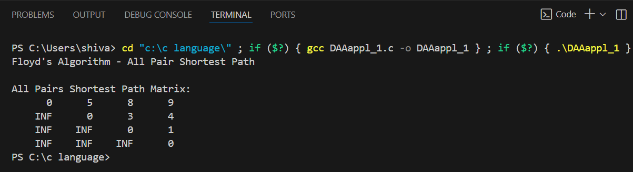

Complexity: –
Time Complexity: – O(V²)
Space Complexity: O(V)

Applications of SSSP
1. Network Routing
- Used in Internet routing protocols (like OSPF, RIP) to find the shortest or least-cost path from one router to all others.
2. GPS and Map Navigation
- Used by GPS systems (like Google Maps) to find the shortest driving or walking routes from one location to all destinations.
3. Transportation and Logistics
- Used to plan delivery routes, airline routes, or railway schedules efficiently.
4. Telecommunication Systems
- Helps determine the minimum-cost communication path between switches or servers.
5. AI and Game Development
- Used in pathfinding algorithms for game characters or robots to move optimally from a start point to targets.
6. Project Scheduling
- In project management (using graphs of tasks and dependencies), SSSP helps find earliest completion times for each task.

Conclusion:-The Single Source Shortest Path algorithm is vital in networking, navigation, logistics, and AI, helping find efficient paths from one source to all destinations.

